Relational Databases: MySQL

# Installation

Is already pre-installed.

# Database Creation

Try to start MySQL client.

$ mysql

You will see an Access Denied error, because MySQL implicitly tries to use your Unix username (**cloudera** in our case), while doesn’t having one registered. Let’s proceed using Cloudera’s builtin root credentials.

$ mysql -uroot -pcloudera

Create a new database.

mysql> create database bedrock;

List all available databases.

mysql> show databases;

Switch to the created one.

mysql> use bedrock;

Create a table.

mysql> create table employee (name char(20), dept char(20), jobtitle char(20));

Show information about it.

mysql> describe employee;

+----------+----------+------+-----+---------+-------+

| Field | Type | Null | Key | Default | Extra |

+----------+----------+------+-----+---------+-------+

| name | char(20) | YES | | NULL | |

| dept | char(20) | YES | | NULL | |

| jobtitle | char(20) | YES | | NULL | |

+----------+----------+------+-----+---------+-------+

3 rows in set (0.00 sec)

List all the tables in the current database.

mysql> show tables;

+-------------------+

| Tables_in_bedrock |

+-------------------+

| employee |

+-------------------+

1 row in set (0.00 sec)

Insert several employee records one-by-one.

mysql> insert into employee values ('Fred Flinstone','Quarry', 'Rock Digger');

mysql> insert into employee values ('Wilma Flinstone', 'Finance', 'Analyst');

mysql> insert into employee values ('Barney Rubble', 'Sales', 'Manager');

mysql> insert into employee values ('Betty Rubble', 'IT', 'Developer');

Now let’s try to add user **cloudera** and launch the client without specifying root credentials.

mysql> create user cloudera;

mysql> quit

$ mysql

Now there is no error, we are in the shell. Let’s try to use our bedrock database.

mysql> use bedrock;

Oops! We forgot to grant privileges on this database to our new user. Let’s fix it!

mysql> quit

$ mysql -uroot -pcloudera

mysql> grant all privileges on bedrock.* to cloudera;

mysql> quit

$ mysql

mysql> use bedrock;

It works! Let’s perform several selects.

mysql> SELECT * from employee;

mysql> SELECT name FROM employee WHERE dept='Sales';

# Data Loading

Create a tab-delimited file load.tsv in your **cloudera**’s home directory. It should contain lines with tab-delimited fields for the bedrock.employee table. The number of tab delimited fields and their order must match the database ones. Example:

Betty Rubble IT Developer

Try to be original and input at least 4 lines of employee entries of your own choosing.  
Copy the contents of the file here:

Helga Eriksson Dataproduction Project lead

Kevin Bacon' Dataproduction Data engineer

Hue Tux' Dataproduction Assistant

Leila Barankova HR Recruiter

Anna Jenkins HR Recruiter

Sandra Rasmussen HR Psychologist

Bob Hunter IT Java developer

Sam Firefly Administration Director

Cassandra Chi Administration Bookkeeper

Load the file data into the bedrock.employee table.

mysql> load data local infile 'load.tsv' into table employee;

Select full contents of the employee table and paste both query and execution results here:

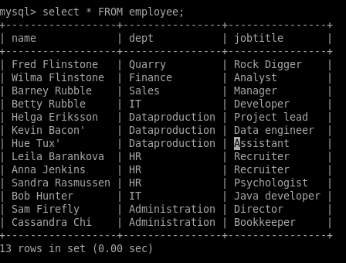

mysql> select * FROM employee;

+------------------+----------------+----------------+

| name | dept | jobtitle |

+------------------+----------------+----------------+

| Fred Flinstone | Quarry | Rock Digger |

| Wilma Flinstone | Finance | Analyst |

| Barney Rubble | Sales | Manager |

| Betty Rubble | IT | Developer |

| Helga Eriksson | Dataproduction | Project lead |

| Kevin Bacon' | Dataproduction | Data engineer |

| Hue Tux' | Dataproduction | Assistant |

| Leila Barankova | HR | Recruiter |

| Anna Jenkins | HR | Recruiter |

| Sandra Rasmussen | HR | Psychologist |

| Bob Hunter | IT | Java developer |

| Sam Firefly | Administration | Director |

| Cassandra Chi | Administration | Bookkeeper |

+------------------+----------------+----------------+

13 rows in set (0.00 sec)